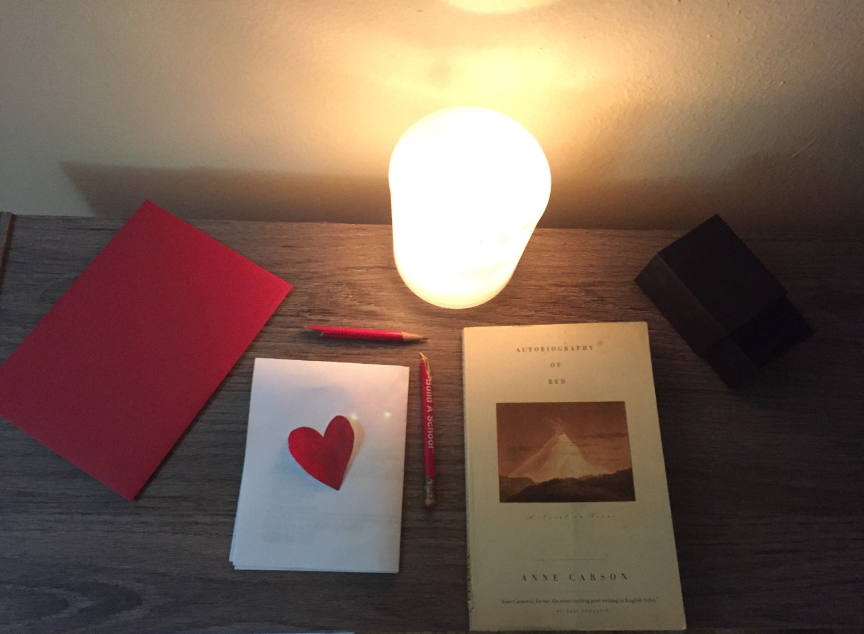

Tuan Nguyen

Book Bento for Autobiography of Red by Anne Carson

Red Envelope

The red envelope is described Geryon who sees all things in red, even in his dreams. Geryon, who is a young boy portrayed and perceived as a self-described monster, with red skin and wings. Geryon’s wing is a metaphor that Anne Carson want to show Geryon’s world of illusion. Whether Geryon’s wing is real or a metaphor that Anne Carson using to describe Geryon’s power. For example, Geryon’s mother neatened his little red wing and pushed him in through the door on his first day of school. On the other hand, Anne Carson could show that Geryon’s mother is comfort and care for Geryon. Although Geryon is identified as a monster, he doesn’t seem dangerous or scary. In fact, he often gets bullied by his older brother. Geryon is a normal teenager who loves to sleep and write an autobiography of himself. In Geryon’s autobiography, he begins with the fact about himself. For instance, Geryon writes that he is a monster everything about him was red. He lived on an island in the Atlantic called the Red Place. He had six hands six feet and wing. Geryon’s mother was a river that runs to the sea and Geryon’s father was gold. In the end, he indicated Herakles come one day and kill Geryon. However, Geryon’s autobiography is based on his own imagination.

A Heart postcard

A heart postcard shows the relationship between Geryon and his mother. When Geryon was little, Geryon’s mother would make his favorite meal on every Tuesday. While Geryon’s mother is sat on the rug with her cigarettes, Geryon worked beside her on his autobiography. Moreover, his mother would bend over and kiss him on the eyes. Geryon’s mother expressing her love for Greyson by kissing him on the eyes and reassuring him that he is not weak. The relationship between Geryon and his mother is unbreakable. Every time Geryon is upset with his brother playing on him, his mother would away comfort him. At night, Geryon’s mother would read book and put him to sleep. Nonetheless, Geryon’s mother seems caring for Geryon, she is careless to the fact that Geryon is sexually abused by his brother.

Black Box

The box shows the secret relationship between Geryon and Herakles, who is Geryon’s lover. Geryon first meets Herakles when he was going to the Bus Depot. Geryon heard someone was asking for change for a dollar. Geryon turns over and responds “no”. Herakles started straight at Geryon. At that moment, Geryon begins to fall in love with Herakles. A few days later, Geryon’s mother asks him about the friend that he has spent all his time with now. Geryon has no response to her. Geryon is keeping the relationship with Herakles as a secret. However, their relationship doesn’t last for long. Herakles eventually lefts Geryon. After their breakup, Geryon feels desperate to believe in true love.

Candle

The candle represented that Geryon’s wings are real. When the candle is lighted, Geryon is flapping his wings. When the candle is blown out, Geryon is hiding his wings from others. In chapter XV. pair, Anne Carson says, “His wings were struggling. They tore against each other on his shoulder like the little mindless red animals they were” (p. 53). Moreover, when Geryon stays at the house of Ancash’s mother, Ancash wraps Geryon in blankets and discovers Geryon’s wings. Later, Ancash knows that Geryon is a Peruvian legend in which people enter a volcano and then fly out with red-skinned and winged. The people who have wings known as eyewitnesses and were highly respected. Geryon starts to see his wings as positive attributes rather than things that make him monstrous and different.

A broken pencil

A broken pencil shows the tragedy relationship between Geryon and Anchas. On the journey to the volcano, Geryon accidentally gets back with Herakles. However, Geryon knows that Herakles has a new partner, who is Ancash. While Herakles and Ancash are on their way gathering data on volcanos, Geryon restarts the relationship with Herakles. Although Geryon knows that Herakles and Ancash are together, he still wants to sleep with Herakles. When Ancash finds out that Geryon is sleeping with Herakles, he gets angry and punches Geryon. However, Ancash forgives Geryon and wants to see Geryon uses his wings to fly. Geryon takes a photograph of himself flying as a gift to Ancash. Finally, three of them get back together and watch the flame of the volcano.